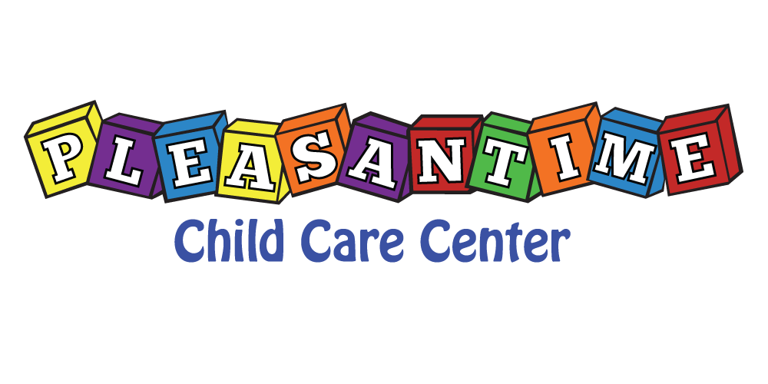
August 3, 2020
Dear PleasanTime Customers,
It is that time of year to plan ahead for Fall 2020-21. The bottom of this form is the sign-up for your child/ren. Indicate your child/ren’s contracted schedule for the Fall starting Monday, August 31, 2020- Friday June 4, 2021 .
To assure a spot for child/ren in our Fall 2020 program, this contracted registration must be received by Friday, August 14, 2020. Feel free to contact Jackie with any questions before the deadline. Please send back to Jackie via email (jwpleasantime@gmail.com) or a paper copy to be placed in the check box.

With Appreciation & Gratitude,
Jackie Ward
Administrator
Fall Registration 2020-21 August 31, 2020-June 4, 2021
Child’s Name _________________________________________
Contracted Days M T W R F
Contracted Times _________________________________________

I understand that I have contracted the days and times specified above. If a change needs to be made, the request shall be done in writing 2 weeks prior to change. I will adhere to my contract.

________________________________________ ____________________________________
Parent/Guardian Signature Date

