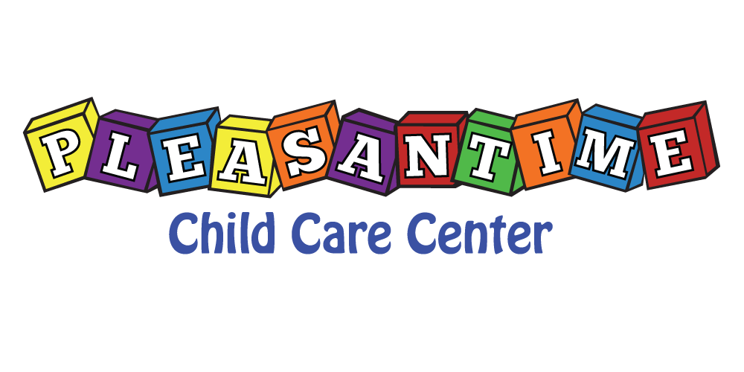
February 3, 2020
Dear PleasanTime Customers,
It is that time of year to plan ahead for Summer 2020. The bottom of this form is the sign-up for your child/ren. Indicate your child/ren’s contracted schedule for the summer starting Monday, June 8, 2020-Thursday August 27,2020 (Friday August 28,2020 is teacher work-day, PleasanTime is closed). This is a paid holiday (August 28) unless vacation time is requested.
To assure a spot for child/ren in our Summer 2020 program, this contracted registration must be received by Friday, February 14, 2020. Feel free to contact Jackie with any questions before the deadline. Please send back to Jackie via email (jwpleasantime@gmail.com).

With Appreciation & Gratitude,
Jackie Ward
Administrator
Summer Registration 2020 June 8-August 27, 2020
Child’s Name __________________________________
Contracted Days M T W R F
Contracted Times ______________________________

I understand that I have contracted the days and times specified above. If a change needs to be made, the request shall be done in writing 2 weeks prior to change. I will adhere to my contract.

________________________________________ ____________________________________
Parent/Guardian Signature Date

